LH2 Codebase Acquisition
The Caller's Playbook — cold call to closed-won
Who it's for: everyone working the Codebase Acquisition pipeline in HubSpot — GTM analysts, meeting owners, and closers.
What we do: we acquire Indian IT-services firms' codebases. A lead travels: cold call → technical meeting → client-run evaluation script → negotiation → contract → data migration → payment → won.
⛔ The rule above all: never make up data.
No number, no name, no answer → leave it blank and note why. A blank is correct; an invented value is a bug.

1 Two roles on every deal — PoC & POD lead
- PoC (Point of Contact) = the person who made the cold call. This never changes for the life of the deal — stored in the PoC field.
- POD lead = whoever is actively driving the deal right now. This is the Deal Owner, and it changes hands twice as the deal moves.

Phase | POD lead (Deal Owner) | Pool
Cold Call → GMeet Fixed | Shreyas | GTM analysts
GMeet Fixed → Script Results Received | Ishpreet | Meeting owners
Script Results Received → Closed/Won | Shobit | Closers

➡ Two mandatory handoffs (a rule, not a suggestion)
1) When you log GMeet Fixed: paste the GMeet link and reassign Deal Owner → Ishpreet.
2) When you log Script Results Received: reassign Deal Owner → Shobit.
The PoC stays the same throughout — only the POD lead (owner) moves.

2 The pipeline at a glance
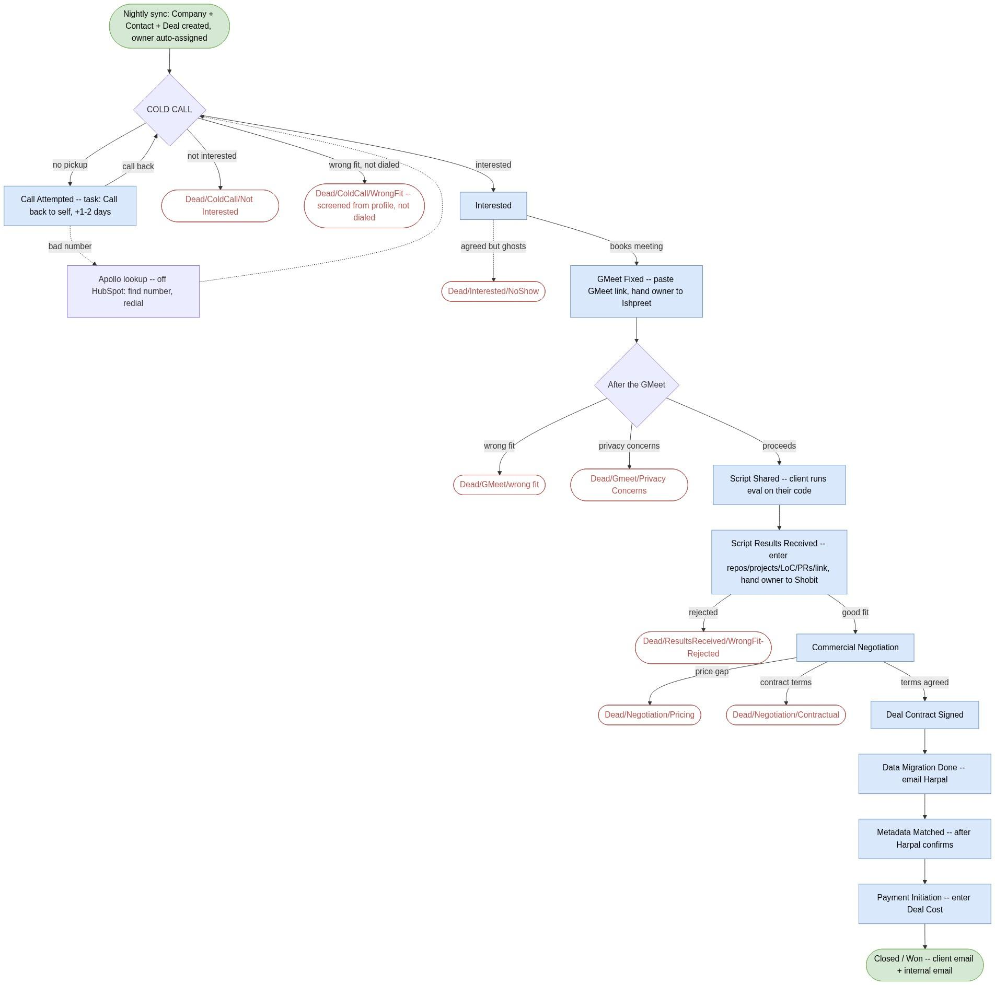
🔒 = fill a field before advancing.
➡ = a mandatory POD-lead handoff.
📝 = every Dead/* needs a note (why) first.

3 Manually add a deal (and fill every field)
Use this to load a deal you already have into HubSpot at its current stage — each person backfills their own book of business.
- CRM → Deals → Create deal (top-right).
- Deal name = company name. Pipeline = Codebase Acquisition. Deal Stage = the stage it's actually at right now (don't dump everything in Cold Call).
- Deal Owner = the current POD lead for that stage (Shreyas / Ishpreet / Shobit). PoC = whoever first called it.
- Associate the Company and Contact — create them if missing (add the founder's phone, LinkedIn, email, role on the contact).
- Fill the fields gated by that stage and every earlier one you know: Deal Value Range ($) if past GMeet · # Repos / # Projects / LoC / PRs / results link if at/after Script Results · Deal Cost ($) if at/after Payment.
- Add a note for context and set Next Follow-up.
✅ Match the stage to reality.
Fill what you truly know; leave the rest blank — never invent a value. A required-field prompt on stage change tells you the minimum that stage needs.

4 Start of your day
- HubSpot → CRM → Deals, pipeline Codebase Acquisition, Board view.
- Filter Deal owner = you (that's the POD lead) → save as “My Deals.”
- Work Cold Call first, then anything with Next Follow-up = today.
- Priority is NOT set at this stage — it's set after the GMeet, by the Lead Manager.

5 The cold call — 4 outcomes

What happened | Move the deal to | Then
Picked up, interested | Interested | Deal Value Range ($) comes later — post-GMeet
Picked up, not interested | Dead/ColdCall/Not Interested | note why (required 📝)
Not our target — decided from the profile before dialing | Dead/ColdCall/WrongFit | note why 📝. No call was made — not a call attempt.
No pickup / busy | Call Attempted | Call-back task to yourself, due in 1–2 days
Wrong / dead number | stay in Call Attempted | Apollo lookup (Section 9), redial

Always log the call (Log activity → Call → outcome + one line).

6 Every stage explained
For each stage: what it means → what you do → what to enter → when to move on.

🔵 Cold Call POD lead: Shreyas
- Means: brand-new lead, never contacted. You are the PoC.
- You do: make the first call; log outcome.
- Move on: Interested / Dead-ColdCall-* / Call Attempted (Section 5).

🔵 Call Attempted POD lead: Shreyas
- Means: tried but didn't connect (no pickup / busy), or bad number.
- You do: create a Call-back task assigned to yourself, due in 1–2 days; Apollo-lookup a bad number first.
- Move on: Interested if they engage; Dead/ColdCall/Not Interested (with a note) if they never respond.

🔵 Interested POD lead: Shreyas
- Means: they want to know more.
- You do: send the meeting invite with the GMeet link.
- Move on: GMeet Fixed if they book. If they agreed but ghost / never make the meeting → Dead/Interested/NoShow (note). Deal Value Range ($) is NOT entered here.

🔵 GMeet Fixed 🔒 + ➡ handoff to Ishpreet
- Means: the technical meeting is booked.
- You do (mandatory): (1) paste the GMeet link into the deal, (2) reassign Deal Owner → Ishpreet. The PoC stays you.
- After the call (Lead Manager, now owner): enter the Deal Value Range ($) and set deal Priority (High/Medium/Low) — both before Script Shared.
- Move on: Script Shared, or Dead/GMeet/wrong fit / Dead/Gmeet/Privacy Concerns (each noted).

🔵 Script Shared POD lead: Ishpreet
- Means: our evaluation script is sent. The client runs it on their own codebase and returns the output. (No NDA here — the only signing is the contract after negotiation.)
- Enter 🔒: Deal Value Range ($) — post-GMeet, required to reach this stage.
- Move on: Script Results Received when the output is back. Set Next Follow-up (+2 days).

🔵 Script Results Received 🔒 + ➡ handoff to Shobit
- Means: we have their script output and LH2 has reviewed code quality.
- Enter 🔒 (all required before the handoff): # Repos · # Projects · Cumulative LoC · Total PRs · Script Results link.
- You do: fill all five → then reassign Deal Owner → Shobit. Don't hand off until all five are in.
- Move on: Commercial Negotiation (good fit) or Dead/ResultsReceived/WrongFit-Rejected (noted).

🔵 Commercial Negotiation POD lead: Shobit
- Means: we've made an offer and are negotiating price/terms.
- Enter 🔒: negotiation notes — our offer, their ask, where it stands.
- Move on: Deal Contract Signed (agreed), or Dead/Negotiation/Pricing / Dead/Negotiation/Contractual.

🔵 Deal Contract Signed POD lead: Shobit
- Means: terms agreed and the contract is signed. This is the only contract signing in the whole flow — here, after negotiation, nowhere earlier.
- Move on: Data Migration Done.

🔵 Data Migration Done POD lead: Shobit
- Means: their codebase/data has been transferred to us.
- You do (mandatory): email Harshpal to request the metadata match, and wait for his reply confirming “metadata matched.”
- Move on: Metadata Matched — only after Harshpal's confirmation.

🔵 Metadata Matched POD lead: Shobit
- Means: Harshpal has verified delivered code against agreed metadata (LoC, repos, PRs) and confirmed by email.
- Move on: Payment Initiation once matched.

🔵 Payment Initiation POD lead: Shobit
- Means: payment is being processed to the client.
- Enter 🔒: Deal Cost ($) — the amount we're paying for the codebase.
- Move on: Closed/Won once paid.

🏆 Closed/Won POD lead: Shobit
- Means: paid, data received and matched. Deal won.
- You do (mandatory): send two emails — (1) client closure email (thank-you / handover), (2) internal notification to the LH2 team.
- Confirm: Deal Cost ($) is filled (for the Executive dashboard).

🔴 Dead stages name = Dead/{Stage}/{Reason}

Died at | Use this dead stage
Cold call — picked up, not interested | Dead/ColdCall/Not Interested
Screened out from profile before dialing | Dead/ColdCall/WrongFit
Said interested but never made the gmeet (ghosted) | Dead/Interested/NoShow
GMeet — turned out wrong fit | Dead/GMeet/wrong fit
GMeet — privacy concerns (won't share code) | Dead/Gmeet/Privacy Concerns
After results — poor code / rejected | Dead/ResultsReceived/WrongFit-Rejected
Negotiation — price gap | Dead/Negotiation/Pricing
Negotiation — contract terms | Dead/Negotiation/Contractual

📝 Every dead is mandatory-noted.
Write one line of why in the deal notes before moving it to any Dead/* stage. No note, no dead.
⏸️ On Hold — a checkbox, not a stage.
Deal alive but paused → tick On Hold + set Next Follow-up. Keeps its stage, drops off the active board until the date. Don't mark it dead.

7 Golden rules
- Never fabricate. Blank + reason beats a guess.
- PoC never changes. POD lead (owner) changes at the two handoffs.
- No pickup → self-assigned Call-back task, due in 1–2 days.
- Deal Value Range ($) is entered POST-GMeet — required before Script Shared, not at Interested.
- GMeet link required at GMeet Fixed — and hand the deal to Ishpreet.
- At Script Results Received: enter # Repos, # Projects, Cumulative LoC, Total PRs, and the Script Results link — then hand to Shobit.
- Negotiation notes required before Deal Contract Signed.
- After Data Migration Done: email Harshpal; move to Metadata Matched only once he replies confirming the match.
- At Payment Initiation enter Deal Cost ($). At Closed/Won send the client closure email + the internal notification.
- Every Dead requires a note (why) first. Pick the exact Dead/Stage/Reason.
- Always log the call + set the next follow-up.
- Priority (High/Medium/Low) is set AFTER the GMeet, by the Lead Manager — not during the cold-call phase.

8 Example walkthrough — a deal that closes
Illustrative. “Acme Software / Priya (founder)” is made up.
- Cold Call (you = PoC, POD lead Shreyas). Priya's interested → Interested. Log call, send the meeting invite.
- Book the meeting → GMeet Fixed: paste GMeet link, hand owner to Ishpreet. (PoC still you.)
- On the GMeet, Priya agrees to run the eval. Post-call, enter Deal Value Range ₹15L → Script Shared. Ishpreet follows up.
- Priya's team returns output → Script Results Received: Ishpreet fills the 5 fields + link, hands owner to Shobit.
- Shobit offers ₹12L, Priya asks ₹18L → Commercial Negotiation, notes: “ours ₹12→₹14L, ask ₹18L, converging ₹15L.”
- Agreed ₹15L → the contract is signed here → Deal Contract Signed.
- Code transferred → Data Migration Done → email Harshpal → “metadata matched” → Metadata Matched → Payment Initiation → 🏆 Closed/Won.
(If Priya had privacy concerns about sharing code on the GMeet → Dead/Gmeet/Privacy Concerns instead.)

9 Apollo lookup — wrong / missing number
A caller-side step, not a HubSpot stage — don't move the deal for it.
- Open the founder's LinkedIn on the contact, or search name + company.
- Find a working number in Apollo.
- Update the contact's Phone in HubSpot.
- Redial. Deal stays in Call Attempted until you connect. If Apollo has nothing, drop a LinkedIn message + set a follow-up — don't guess.

10 Quick reference card

Situation | Stage / action
New lead | Cold Call (you = PoC)
Interested | Interested (Deal Value Range comes later)
No pickup / busy | Call Attempted + Call-back task to self, 1–2d
Bad number | Call Attempted + Apollo lookup
Meeting booked | GMeet Fixed + GMeet link + owner → Ishpreet
After GMeet call | enter Deal Value Range ($) → Script Shared
Eval running | Script Shared
Got script output | Script Results Received + repos/projects/LoC/PRs/link → owner → Shobit
Negotiating | Commercial Negotiation + notes
Contract signed | Deal Contract Signed
Data received | Data Migration Done → email Harshpal
Harshpal confirms match | Metadata Matched
Paying client | Payment Initiation
Paid + done | 🏆 Closed/Won
Paused | tick On Hold + follow-up
Died — any stage | pick Dead/Stage/Reason + note why (required)

11 HubSpot how-to
- Move a stage: drag the card, or open the deal → change Deal Stage. Required fields prompt automatically.
- Reassign POD lead: open the deal → change Deal Owner to the next person (Ishpreet, then Shobit).
- PoC: set once at Cold Call in the PoC field — never change it.
- Log a call / follow-up / priority / on-hold: all on the deal record, right panel.
- Find the founder's contact: the associated Contact holds phone, LinkedIn, email, role.

12 Mail templates per stage
To be supplied by the team. Slots reserved:

Stage | Mail template
Interested → GMeet invite | TBD (must include the GMeet link)
Script Shared | TBD (script instructions, if any)
Commercial Negotiation | TBD (offer email, if any)
Deal Contract Signed | TBD (contract email, if any)
Data Migration Done → Harshpal | TBD (metadata-match request; reply = “metadata matched” gate)
Closed/Won → Client | TBD (closure / handover / thank-you)
Closed/Won → Internal | TBD (won + delivered notification)

If a step doesn't match what you see in HubSpot, flag it — don't guess. The pipeline stages in HubSpot exactly match this document.

OutFlo — Calling Guide
Where: HubSpot → Deals → Campaign pipeline. All assigned to you, tagged “Outflo Outreach – India / Indonesia.” These are people we messaged on LinkedIn via OutFlo.
Call in this order — use the Priority field

Priority | What it means | When to call
🔴 High | They REPLIED to our LinkedIn message. Read their reply in the deal Note first. | First
🟠 Medium | They ACCEPTED our connection request but haven't replied. | Next
🟡 Low | Connection request sent 2+ days ago, not yet accepted. | After High/Med
(none) | Already have a status from the tracker sheet, or a booked meeting. | As relevant
Stage tells you the state
- Cold Call → these are the ones to dial.
- GMeet Fixed → meeting already booked (prep, don't cold-call).
- Interested / Script Shared / Call Attempted → already in progress.
- Dead → skip.
On each lead
- Phone number (where we found one — ~70% have one) + LinkedIn URL.
- A Note with their reply text, when they connected/replied, and which account messaged them.
- India / Indonesia tag.
Workflow
- Sort the Campaign board by Priority (High → Low).
- Open the lead and read the Note (reply text + history).
- Dial the phone number.
- Log the call and move the stage (Interested / GMeet Fixed / Dead-with-reason).
Leads refresh from OutFlo periodically — new repliers/connectors appear at the top by priority.

